Proposal Cover Sheet
Term: Fall__2011___ Spring _____ Year ______
Instructor ____Nora Demers_________

Name: _____Ashley Brown_____________________________________

Present Year in Education (e.g., freshman, sophomore, etc.): ________senior____________

E-mail Address: ______ambrown0564@eagle.fgcu.edu_______________________

Major ________Chemistry______________________________

Have you identified a research mentor for a senior thesis (if applicable)?
_____ Yes _____ No.

If yes, please identify.

Name: __________________________________________

Title of Proposal:

____Building and Testing of HKUST-1, a metal organic framework, with α-alumina supports as a New Water Filtration System _________________________________

Keywords (3-5)
_______HKUST-1; metal organic framework; Water Filtration__________________________
Checklist:
All required portions of the first submission are included ___✓__ Yes _____ No

I had an external reviewer read the proposal _✓____ Yes _____ No

If Yes, who _____Dr. McManus and Aaron Farnsworth___When ____10/16/11-10/18/11___

I authorize the use of this proposal as an example in future courses ___✓__ Yes _____ No

Abstract
In developing and transitional countries, many people do not have purified drinking water, and through this project people may now have it. This project is about building and testing HKUST-1, a metal organic framework, as the filter with support disks made of α-alumina to hold it up. In this project, the process of building will be done using the procedure made by Nan et al, but the testing will be done using normal procedures that are used to test for contaminants different types of water. This will impact water technology, inorganic chemistry research, and on people as a whole.

Table of Contents
Introduction 3

Research Objective 4

Methods 4

Broader Implications 7

Time table and Project management 7

References 9

Curriculum Vitae 10

Introduction

Drinkable water is very important to every nation and people. In many developing and transitional countries, most people do not have access to clean and pure drinking water, filtration is a lost cost way and is used to take out certain amounts of other elements, but also to eliminate microbes that cause some diseases (Peter-Varbanets, Zurburgg, Swartz, & Pronk, 2009). There are methods now of cleaning and disinfecting water by way of using ultraviolet (UV) light or by other chemical agents (Shannon, Bohn, Elimelech, Georgiadis, Marinas, & Mayes, 2008). The UV light method is very effective at killing microbes, but needs a secondary system to check them because it does not have any residual effects that keep killing them over time (Runia, W., 1995). After the UV light process, other forms of disinfection are used to check if all of the microbes are dead. The secondary systems are there are so that no bacterial contaminants, like malaria, and viral contaminants are in drinking water. Using other filtration methods helps to remove the dead organisms from the water (Runia, W., 1995).
Metal organic frameworks (MOFs) and their supports can become the secondary system to filter out contaminants and to allow water to pass by freely. MOFs are crystalline compounds made up of metal ions or clusters with organic ligands that connect to form one-dimensional to three-dimensional structures (Kuppler, Timmons, et al., 2009, Ma, 2009). These frameworks arose from zeolites and how they work (Caro, Noack, Kolesh, & Schafer, 2000). Zeolites are naturally porous minerals that can adsorb gases in a variety of environments (Caro, et al., 2000). MOFs are the man- made versions that are more easily manipulated and with the effectiveness being increased to adsorb gases (Roswell, & Yaghi, 2004).
HKUST-1, one of the most known MOFs, has the ability to adsorb sulfur –based gases (Chui, Lo, Charmant, Orpen, & Williams, 1999). Another property it has is that the ligands can be switched from aqua-based to pyridine based, and it is electronically neutral (Chui, et al., 1999). The formula for HKUST-1 (Figure 1) is [Cu₃(TMA)₂(H₂O)₃]_{n}, and was synthesized from copper and trimesic acid (Chui, et al., 1999).
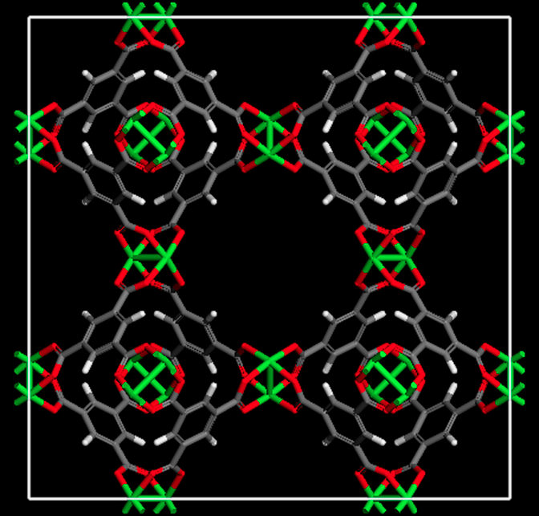
Problems arise in building the framework because it is not able to hold itself up, so there is need of a support system for HKUST-1 to be built on (Nan, Dong, Wang, Jin, & Xu, 2011). Building the framework with some assembled parts (the supports) and only HKUST-1 will be grown in the conditions set up by Nan, et al (2011).
Figure 1: HKUST-1 Framework

This part is the building of the filter, but the other part is to test it in normal conditions of a water purification plant, and in a home setting. Before testing the full barrier, there will be tests using X-ray crystallography to be sure that HKUST-1 was built properly on to the support system. The last part is testing all of the filters to see if any contaminants came through.
Research Objective
A metal organic framework, HKUST-1, with support, will be tested for its effectiveness as a filter to stop contaminants in different types of water. The hypothesis for this study is that HKUST-1 will filter out bacterial and viral contaminants and may stop high concentrations of metals in distilled, tap, and lake water at Florida Gulf Coast University.
Methods
Study Design:
Filter and Framework Construction
In this study, I will be testing experimentally if HKUST-1 will work as a filter in an aqueous solution. At the beginning of the study, I will be building the filter using the process for HKUST-1 has been developed by Nan, Dong, Wang, Jin, & Xu (2011). Just like Nan et al, I will be using a step-by-step (SBS) seeding procedure to form and crystalize HKUST-1 on a mesoporous α-alumina disk (2011). I will repeat a four-part cycle that includes dipping it in 1 mM of H₃btc, ethanol, Cu ²⁺ solution, and ethanol again to complete it, producing twenty-one HKUST-1 disks. Before finishing the filter, I will perform supplementary tests to make HKUST-1 is built properly. In addition to the first disk affixed in the experiment done by Nan et al, I will attach another one on the other side of HKUST-1 through the method of covalent previously used (2011).
Filter System Design
I will set up a gravitational filtration system that Peter-Varbanets et al states is used in developing countries to test the filter using four different types of water: distilled, spiked distilled, tap, and lake water at Florida Gulf Coast University-FGCU (2009). A hatch at the top of the mechanism will let the water flow down at the speed of gravity to test if the filter can take the force of the water in simple conditions. I will also spike two trials of distilled water with malaria, another two with a divalent cation, and the last two with west Nile virus, to show if the filter will work.
Testing the Filter
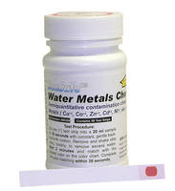
The testing phase will show if HKUST-1 with support can filter out metals, organic compounds, bacteria, and some viruses. Five of the new filters will be used as the control, which is in distilled water. The other three sets will be tested in spiked distilled water, tap water, and lake water at FGCU to see if HKUST-1 can stop contaminants. The first test will detect any change in weight of in the filter in each trial to show if any degradation occurs. The first method for testing contaminants that I will use is for testing metal concentrations to show if any divalent cations passed through the filter in solution, because α-alumina disk could possibly degrade. Figure 1 is an example of what I am going to use as the test, and does for metals that comes with the colored chart that gives what color goes with an approximated concentration in micrograms per liter. For second detection method, I will use another type of test strip that tests for organic compounds to test degradation of HKUST-1 or if any other compounds got through. The third detection method I will use is multiplex polymerase chain reaction or PCR testing if west Nile virus and malaria come through the filter (Fong & Lipp, 2005).
Figure 2: SenSafe test kit
Data Collection:
The data I will be collecting is from each of the four tests explained above. From the first test, I will collect the change in weight to test if the filter degrades, shown by Table 1.
Table 1: Degradation Tests
Trial # | Time | Test # | Initial Weight | Final Weight | Mean Weight
1-5  Control group | Amount of in the water each trial | 1-3 for each | In grams for each test | In grams  For each test | For each test
For the second test, I will collect the changes in concentrations of metals to see if HUKST-1 filters metals. For the third and fourth tests, I will collect categorical data like color to relate it to the chart for molarity that are given by the testing kits use a table much like table two.
Table 2: Detection Tests (metals)
Trial # | Test # | Color | Concentration according to chart
1-15 | 1-3 for each trial | Looks like | Micrograms per L
The detection methods will have tables much like this to shows the observations of all of the colors that appeared in the trials. Each of these tests will be done three times per trial to have enough data to make an accurate conclusion.
Data Analysis:
The results of the degradation test will be expressed in the mean change in weights of the filter per trial in grams. To show if there is any difference in degradation of the filter between the different types of water, I will be using the students’ t-Test.
For the second, third, and fourth tests, I will use the chi-square test to show the relationship between how well the filter works in filtering out each of the different contaminants. The p-value for all of the tests will be p<0.001.
Broader Implications
Some of the broader implications for this study are that if this is tested many times it can become a cost-effective water filter in many countries. Many countries in Africa need good systems usable from the materials they have or can be produced in an industrialized country and brought to them to make rainwater harvesting easier and safer. Another implication is that metal organic frameworks have many more possibilities then are known right now, and will not be as limited as they are.
Time Table and Project Management
1st Month | Get approval and discuss project with advisors; also ask people to help in the building, data collection and analysis phases; gather materials; find people to do the PCR tests.
2nd Month | Start building the 21 disk filters and using x-ray crystallography to test HKUST-1; start building the Gravitational filtration systems Get samples of malaria, and west Nile viruses, and divalent cation.
3rd Month | Finish building both the disks and the systems. Start testing the trials.
4th Month | Do the control trials, then the spiked trial, then the tap water and lake water trials, collect all data.
5th Month | Start Data analysis and creating the report for advisors and other people
6th Month | Data analysis and Conclusion finished by the end of the month to present to whoever needs to see it.

I will be there through out the project and will need help to keep it on schedule. I think an advisor would be great for me to stay on task. I will require help to build the filters using the process because of the amount, but the experiment will be completely feasible to do in this amount of time. The longest parts of this experiment will be the building and analysis of the filter and the data.

References

Caro, J., Noack, M., Kolesh, P., & Schafer, R. (2000). Zeolite membranes- state of their development and perspective. Microporous and Mesoporous Material, 3-24.

Fong, T.-T., & Lipp, E. (2005). Enteric Viruses of Humans and animals in Aquatic Environments: Health Risks, Detection, and Potenial Water Quality Assessment Tools . Microbiology and Molecular Biology Reviews , 357-371.

Kuppler, R. J., Timmons, D. J., Fang, Q.-R., Li, J.-R., Makal, T. A., Young , M. D., et al. (2009). Potential applications of metal-organic frameworks. Coordination Chemistry Reviews, 253, 3042-3066.

Ma, S. (2009). Gas adsorption applications of porous metal–organic frameworks. Pure Application Chemistry , 81, 2235-2251.

Nan, J., Dong, X., Wang, W., Jin, W., & Xu, N. (2011). Step-by- Step Seeding Procedure for Preparing HKUST-1 Membrane. Langmuir , 4309-4312.

Peter-Varbanets, M., Zurburgg, C., Swartz, C., & Pronk, W. (2009). Decentralized systems for portable water and the potential of membrane technology. Water Research , 245-265.

Roswell, J. L., & Yaghi, O. M. (2004). Metal–organic frameworks: a new class of porous materials. Microporous and Mesoporous Materials, 73, 3-14.

Shannon, M., Bohn, P., Elimelech, M., Georgiadis, J., Marinas, B., & Mayes, A. (2008). Science and Technology for water purification in the coming decades. Nature , 301-311.

Curriculum Vitae
Ashley Brown
1900 Birkdale Ave.
N. Fort Myers, FL 33903
ambrown0564@eagle.fgcu.edu

GOALS
The goal of my career is to work in the field of water purification and hydrology to make the world have safer and sustainable ways to filter all types of water.

EDUCATION
BA in Chemistry from Florida Gulf Coast University (2012)
Post-Bachelorette Studies: Planning to get a master’s or doctorate in Hydrology
High School: Graduated from Fort Myers High School in 2007 with the IB Diploma

Courses:
Inorganic Chemistry and lab
Physical Chemistry for the Life Sciences and lab
Organic Chemistry I & II and labs
Physics I & II and labs
Biology I & II and labs

PROFESSIONAL SOCIETIES
Chemistry Club @ FGCU
ACS- American Chemical Society

SERVICE
Volunteer:
Mission Trip to Costa Rica
Mission Trip to Mexico
Mission Trips to Oklahoma (3 times)

Academic Service:
Shriner’s Children’s Hospital

Community Outreach:
Helped Design a Brochure for FUNdemental Fitness 4 Kidz
- a brand new non-profit organization
CCFW- Cape Coral Friend of Wildlife
- Helps the Burrowing owls in Cape Coral, FL

SCIENTIFIC SKILLS

- Have Experiences with many types of laboratory equipment and methods of the equipment, and in both biological and chemical fields.

